Class | Time | Monday | Tuesday | Wednesday | Thursday | Friday | Saturday | Total for 6wk Session
Parent Tots  18 mo-2yrs | 45 min | 10:30 - 11:15  6:15 – 7:00 | 9:15 – 10:00 | 10:15 – 11:00  6:25 – 7:10 | 10:15 – 11:00 |  | 10:15 – 11:00 | $80.40
Tumbling Tots  3 yrs. | 45 min | 10:30 – 11:15  5:15 – 6:00 | 10:15 – 11:00  5:15 – 6:00 | 9:15 – 10:00 | 9:15 – 10:00  6:20 – 7:05 | 9:15 – 10:00 | 11:15 – 12:00 | $80.40
Mighty Mites  4 yrs. | 60 min | 9:15 – 10:15  1:00 – 2:00  5:15 – 6:15  6:30 – 7:30 | 9:15 – 10:15  1:00 – 2:00  5:15 – 6:15 | 11:10 – 12:10  4:00 – 5:00  6:20 – 7:20 | 10:30 – 11:30  5:15 – 6:15 |  | 9:00 – 10:00 | $90.00
Stars  5 yrs. | 60 min | 9:15 – 10:15  1:00 – 2:00  5:15 – 6:15  6:30 – 7:30 | 9:15 – 10:15  1:00 – 2:00  5:15 – 6:15 | 11:10 – 12:10  4:00 – 5:00  6:20 – 7:20 | 10:30 – 11:30  5:15 – 6:15 |  | 9:00 – 10:00 | $90.00
Hot Shots  4 & 5 yrs.  Coach approve | 60 min | 9:15 – 10:15  6:30 – 7:30 | 10:15 – 11:15  5:15 – 6:15 | 1:00 – 2:00  4:00 – 5:00 | 9:15 – 10:15  5:15 – 6:15 |  | 11:30 – 12:30 | $90.00
Super Stars  4 & 5 yrs  Coach approve | 60 min | 9:15 – 10:15  6:30 – 7:30 | 10:15 – 11:15  5:15 – 6:15 | 1:00 – 2:00  4:00 – 5:00 | 9:15 – 10:15  5:15 – 6:15 |  | 11:30 – 12:30 | $90.00
Home School  6 and up | 60 min | 1:00 – 2:00 | 1:00 – 2:00 | 1:00 – 2:00 |  |  |  | $90.00
Beginner 1 & 2  6 and up | 60 min | 4:00 – 5:00 | 6:30 – 7:30 | 4:45 – 5:45 | 4:00 – 5:00 |  | 10:15 – 11:15 | $90.00
Beginner 3 | 60 min | 4:00 – 5:00  5:15 – 6:15  7:00 – 8:00 | 4:00 – 5:00  6:15 – 7:15 | 5:15 – 6:15  6:45 – 7:45 | 4:45 – 5:45  6:00 – 7:00  7:15 – 8:15 |  | 9:00 – 10:00 | $90.00
Beginner 4 | 60 min | 4:00 – 5:00  5:15 – 6:15  7:00 – 8:00 | 4:00 – 5:00  6:15 – 7:15 | 5:15 – 6:15  6:45 – 7:45 | 4:45 – 5:45  6:00 – 7:00  7:15 – 8:15 |  | 9:00 – 10:00 | $90.00
Intermediate 1 | 90 min | 5:15 – 6:45 | 4:30 – 6:00  6:30 – 8:00 | 4:00 – 5:30  5:00 – 6:30 | 6:30 – 8:00 |  | 9:00 – 10:30 | $114.00
Intermediate 2 | 90 min | 5:15 – 6:45 | 4:30 – 6:00  6:30 - 8:00 | 4:00 – 5:30  5:00 – 6:30 | 6:30 – 8:00 |  | 9:00 – 10:30 | $114.00
Intermediate 3 | 90 min | 6:15 – 7:45 | 6:15 – 7:45 |  | 4:30 – 6:00 |  | 10:45 – 12:15 | $114.00
Intermediate 4 | 90 min | 6:15 – 7:45 | 6:15 – 7:45 |  | 4:30 – 6:00 |  | 10:45 – 12:15 | $114.00
Advanced 1 | 90 min | 4:30 – 6:00 |  | 6:00 – 7:30 | 6:15 – 7:45 |  |  | $114.00
Advanced 2 | 90 min | 4:30 – 6:00 |  | 6:00 – 7:30 | 6:15 – 7:45 |  |  | $114.00
Advanced 3 | 2 hrs. |  | 6:45 – 8:45 |  | 6:45 – 8:45 |  |  | $126.00
Advanced 4 | 2 hrs. |  | 6:45 – 8:45 |  | 6:45 – 8:45 |  |  | $126.00
High School | 2 hrs. | 7:00 – 9:00 |  | 7:00 – 9:00 |  |  |  | $126.00
Ninja  Beginner | 60 min | 4:00 – 5:00 | 6:30 – 7:30 |  | 5:10 – 6:10 |  | 9:00 – 10:00 | $96.00
Ninja  Intermediate | 60 min | 5:15 – 6:15 |  | 6:30 – 7:30 |  |  | 11:30 – 12:30 | $96.00
Ninja Advanced | 60 min | 6:15 – 7:15 |  |  |  |  |  | $96.00
Parkour Sports  4 & 5 years | 60 min | 5:15 – 6:15 | 4:00 – 5:00 |  |  |  |  | $96.00
Parkour Sports  Beginner | 60 min |  | 5:15 – 6:15 | 4:00 – 5:00 | 4:00 – 5:00  6:20 – 7:20 |  | 10:15 – 11:15 | $96.00
Parkour Sports  Intermediate | 60 min | 7:30 – 8:30 | 7:45 – 8:45 | 5:15 – 6:15 | 7:30 – 8:30 |  |  | $96.00
Parkour Sports  Advanced | 90 min |  |  |  | 7:00 – 8:30 |  |  | $120.00
Session 4
Session 4: May 2 – June 12, 2021 (6week session
Sign up starts
April 19 – 24 for students in session 3
April 26 – May 1 for new students
Closed Memorial Day Weekend May 29th – May 31, 2021

Schedule is subject to change! Minimum of 4 kids per class
www.laketowngym.org | 952-368-flip {3547} | 654 industrial blvd | Waconia

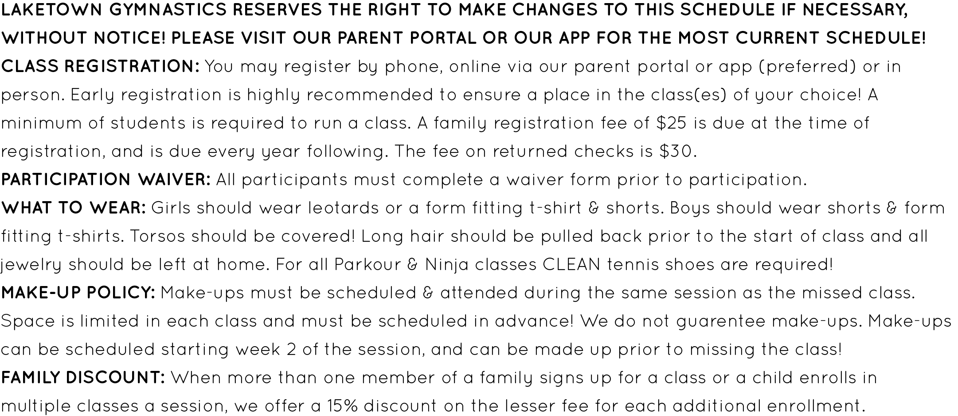
Summer Camps: Time: 1:00 pm to 3:00 pm
Rec Camps ages 6 and up: June 14th – 17th Cost: $99.00
Rec Camps ages 6 and up: July 12th – 15th Cost: $99.00
Parkour/Ninja Camp: ages 6 -12: August 9th – 12th Cost: $99.00
Rec Camps ages 6 and up: August 16th – 19th Cost: $99.00

